 



**UNITED INSTITUTE OF MANAGEMENT (FACULTY OF UNDERGRADUATE**

**STUDIES)**

**BCA**

**Mini Project (Final Report)**

**Explore Beyond Border Exception With GO TRIP Website**

Project Guide: Mr. S.Q Kazmi

Submitted By:

**Team Member:**

**Mayank Pandey (2212105201105) Utkarsh Tripathi(2212105201209)**

**Pranjal Rai (2212105201125)**

**Jatin Tiwari (2212105201093)**

**Acknowledgement**



This project is based on ‘Trip and Travelling Website.’ Working on this has made us to learn a lot of new things that would surely help us in future endeavours.

We would like to present our heartfelt gratitude to United Institute of Management – Faculty of Undergraduate Studies for giving us the opportunity to present this project as a Mini Project of Bachelors of Computer Applications Which is Affliated from Prof. Rajendra Singh (Rajju Bhaiya) University, Prayagraj.

I would like to express my heartfelt gratitude to united institute of management (FUGS) and Dr. Devendra Kumar Tiwari (Principal Sir) for giving us the opportunity to work under their guidance and help us gain immensely enriching professional experience. My sincere thanks to my project in charge and guide, Mr. Qamrul Kazmi sir for giving us valuable inputs and ideas right from the selection of topic till it’s successfull completion

We are also expressing thanks to our parents and friends who have directly or indirectly helped in this.

**Content**



### Sr. No. Title Page No

1. **Introduction 4**

* Introduction to the system……………………
* Problem definition……………………………
* Aim…………………………………………..
* Purpose………………………………………
* Need of the system…………………………...

### Technology Used 5-12

* + Introduction…………………………………
  + Software requirement………………………
  + Hardware requirement……………………...

### Module Description 13

1. **Data Flow Diagram 14-17**
   * Use case diagram…………………………....
   * 0-Level DFD…………………………………

|  |  |  |
| --- | --- | --- |
| **5 Code file structure** | | **21-22** |
| **6 Code file** | | **23-30** |
| **7 Objective** | | **31** |
| **8 Future Scope** | | **32** |
| **9** | **Conclusion** | **33** |



## INTRODUCTION

* Go Trip is an online portal that provide an user friendly and easy way for travelling.
* It is Provide flexibility and efficiency to book any trip or accommodation.
* There are 3 types of user can use Go Trip guest user , registered user and admin.
* Admin can also add or delete records admin panel.
* Problems definition
* Tourist find out difficulties in planning their trip
* Hardly availability of full information and costs much time even for few information
* Problems in finding the shortest path between routes
* Need to based on the paper map or human instructor. ..
* Aim

"To inspire, facilitate, and enhance travel experiences worldwide by providing comprehensive, user-friendly information and booking services."

The purpose of travel sites is to make it easier for people to plan and book their trips. They provide a wide range of services, from helping you find the best deals on flights and hotels, to providing detailed information about destinations around the world.

**Introduction:**

## TECHNOLOGY USED

In this, the software and hardware requirements are mentioned, which are necessary for successfully running this web-app. The system analyst has to determine what software package is best for the “E-Commerce Bakery” and, where software is not an issue, the kind of hardware and peripheral needed for the final conversion.



### Software requirements:

* Technology **Node.js**

Node.js is an open-source, cross-platform, back-end JavaScript runtime environment that runs on the V8 engine and executes JavaScript code outside a web browser. Node.js lets developers use JavaScript to write command line tools and for server-side scripting— running scripts server-side to produce dynamic web page content before the page is sent to the user's web browser. Consequently, Node.js represents a "JavaScript everywhere" paradigm,

unifying web-application development around a single programming language, rather than different languages for server-side and client-side scripts.

The Node.js distributed development project was previously governed by the Node.js Foundation, and has now merged with the JS Foundation to form the OpenJS Foundation, which is facilitated by the Linux Foundation's Collaborative Projects program.

Corporate users of Node.js software include GoDaddy, Groupon, IBM, LinkedIn, Microsoft, Netflix, PayPal, Rakuten, SAP, Walmart, Yahoo!, and Amazon Web Services.



* IDE **Visual Studio Code**

Visual Studio Code, also commonly referred to as VS Code, is a source-code editor made by Microsoft for Windows, Linux and macOS. Features include support for debugging, syntax highlighting, intelligent code completion, snippets, code refactoring, and embedded Git. Users can change the theme, keyboard shortcuts, preferences, and install extensions that add additional functionality.

In the Stack Overflow 2021 Developer Survey, Visual Studio Code was ranked the most popular developer environment tool, with 70% of 82,000 respondents reporting that they use it.

Visual Studio Code is a source-code editor that can be used with a variety of programming languages, including Java, JavaScript, Go, Node.js, Python, C++ and Fortran. It is based on the Electron framework, which is used to develop Node.js Web applications that run on the Blink layout engine. Visual Studio Code employs the same editor component (codenamed "Monaco") used in Azure DevOps (formerly called Visual Studio Online and Visual Studio Team Services).

Visual Studio Code includes multiple extensions for FTP, allowing the software to be used as a free alternative for web development. Code can be synced between the editor and the server, without downloading any extra software.

Visual Studio Code allows users to set the code page in which the active document is saved, the newline character, and the programming language of the active document. This allows it to be used on any platform, in any locale, and for any given programming language.

Visual Studio Code collects usage data and sends it to Microsoft, although this can be disabled. Due to the open-source nature of the application, the telemetry code is accessible to the public, who can see exactly what is collected.



* Operating System **Widows (or any other GUI based)**
* Client-side technologies **HTML, CSS, JavaScript, Bootstrap**

**HTML:**

The HyperText Markup Language or HTML is the standard markup language for documents designed to be displayed in a web browser. It can be assisted by technologies such as Cascading Style Sheets (CSS) and scripting languages such as JavaScript.

Web browsers receive HTML documents from a web server or from local storage and render the documents into multimedia web pages. HTML describes the structure of a web page semantically and originally included cues for the appearance of the document.

HTML elements are the building blocks of HTML pages. HTML provides a means to create structured documents by denoting structural semantics for text such as headings, paragraphs, lists, links, quotes and other items. HTML elements are delineated by tags, written using angle brackets. Tags such as

<img/> and <input/> directly introduce content into the page. Other tags such as

<p> surround and provide information about document text and may include other tags as sub-elements. Browsers do not display the HTML tags but use them to interpret the content of the page.

HTML can embed programs written in a scripting language such as JavaScript, which affects the behavior and content of web pages. A form of HTML, known as HTML5, is used to display video and audio, primarily using the <canvas> element, in collaboration with JavaScript.



**CSS:**

Cascading Style Sheets (CSS) is a style sheet language used for describing the presentation of a document written in a markup language such as HTML. CSS is a cornerstone technology of the World Wide Web, alongside HTML and JavaScript.

CSS is designed to enable the separation of presentation and content, including layout, colors, and fonts. This separation can improve

content accessibility; provide more flexibility and control in the specification of presentation characteristics; enable multiple web pages to share formatting by specifying the relevant CSS in a separate .css file, which reduces complexity and repetition in the structural content; and enable the .css file to be cached to improve the page load speed between the pages that share the file and its formatting.

Separation of formatting and content also makes it feasible to present the same markup page in different styles for different rendering methods, such as on- screen, in print, by voice (via speech-based browser or screen reader), and on Braille-based tactile devices. CSS also has rules for alternate formatting if the content is accessed on a mobile device.

The name cascading comes from the specified priority scheme to determine which style rule applies if more than one rule matches a particular element. This cascading priority scheme is predictable.

The CSS specifications are maintained by the World Wide Web Consortium (W3C). Internet media type (MIME type) text/css is registered for use with CSS by RFC 2318 (March 1998). The W3C operates a free CSS validation service for CSS documents.



#### JavaScript:

JavaScript often abbreviated JS, is a programming language that is one of the core technologies of the World Wide Web, alongside HTML and CSS. Over 97% of websites use JavaScript on the client side for web page behavior, often incorporating third-party libraries. All major web browsers have a dedicated JavaScript engine to execute the code on users' devices.

JavaScript is a high-level, often just-in-time compiled language that conforms to the ECMAScript standard. It has dynamic typing, prototype-based object- orientation, and first-class functions. It is multi-paradigm, supporting event- driven, functional, and imperative programming styles. It has application programming interfaces (APIs) for working with text, dates, regular expressions, standard data structures, and the Document Object Model (DOM).

The ECMAScript standard does not include any input/output (I/O), such as networking, storage, or graphics facilities. In practice, the web browser or other runtime system provides JavaScript APIs for I/O.

JavaScript engines were originally used only in web browsers, but are now core components of some servers and a variety of applications. The most popular runtime system for this usage is Node.js.

Although Java and JavaScript are similar in name, syntax, and respective standard libraries, the two languages are distinct and differ greatly in design.

Express js:

Covered By: Jatin Tiwari

* Express is a minimal and flexible node.js web application framework that provide a robust set of features for web and mobile application.



Express is a minimal and flexible node.js web application framework that provide a robust set of features for web and mobile application.



* **Server Setup**: This member can set up the Express.js server to handle HTTP requests from the frontend and manage routes for different functionalities such as user authentication, hotel search, and booking.
* **API Development**: They will be responsible for developing RESTful APIs that communicate with the MongoDB database, ensuring data is properly fetched, updated, and delivered to the frontend.
* 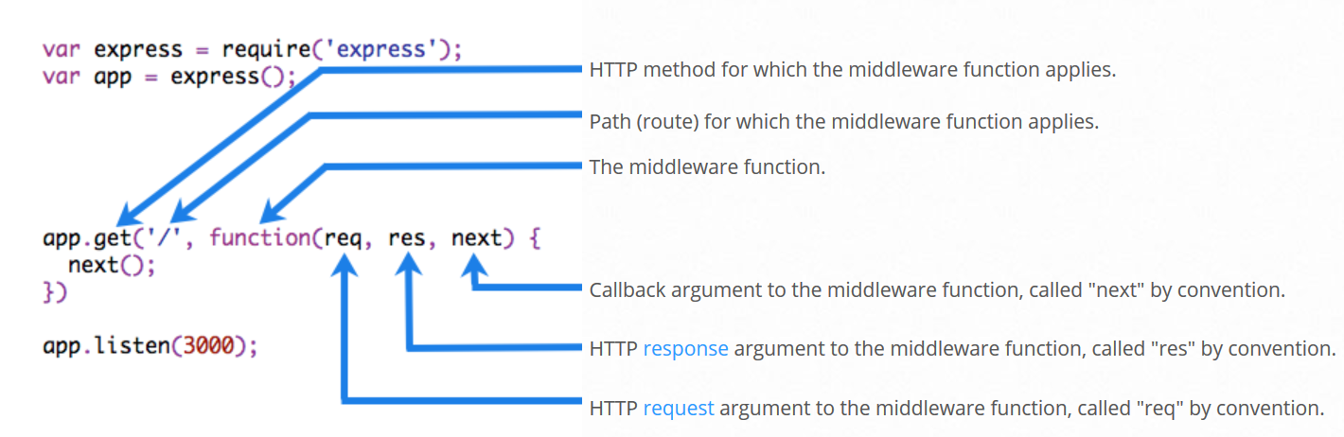**Middleware**: Handling middleware functions, like authentication and authorization, to secure the routes and endpoints is a crucial part of their role



* Server-side technologies **Node.js**
* Database server **MongoDB**

MongoDB stores data in flexible, JSON-like documents, meaning fields can vary from document to document and data structure can be changed over time

The document model maps to

the objects in your application code, making data easy to work with.

Ad hoc queries, indexing, and real time aggregation provide powerful ways to access and analyze your data

MongoDB is a distributed database at its core, so high availability, horizontal scaling, and geographic distribution are built in and easy to use

MongoDB is free to use. Versions released prior to October 16, 2018 are published under the AGPL. All versions released after October 16, 2018, including patch fixes for prior versions, are published under the Server Side Public License (SSPL) v1.



### Hardware requirements:

* Processor **i-3 (or higher)**
* RAM **4 GB (or higher)**
* Storage **64 GB (or more)**



## MODELING MYTHOLOGY

### Model used:

In this project on of **SDLC** model which is **Agile Model**, is used for the development processes.

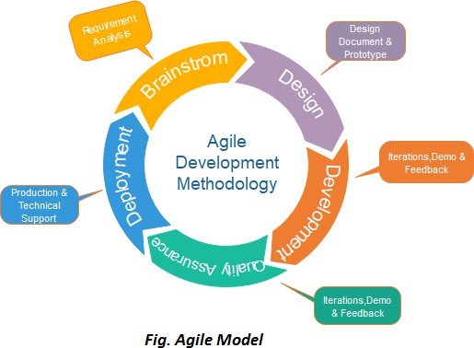**Agile Model** is a combination of iterative and incremental process models with focus on process adaptability and customer satisfaction by rapid delivery of working software product. Agile Methods break the product into small incremental builds. These builds are provided in iterations.

Each iteration typically lasts from

about one to three weeks. Every iteration involves cross functional teams working simultaneously on various areas like –

* Planning
* Requirement Analysis
* Design
* Coding
* Testing
* Deployment

At the end of the iteration, a working product is displayed to the customer and administrator or admin.



## MODULE DESCRIPTION

The web-app consist of following given modules including:

### Register/Login Module:

In this module user/admin has given and LogIn/SignUp option from where one can access or use the full service of the site.

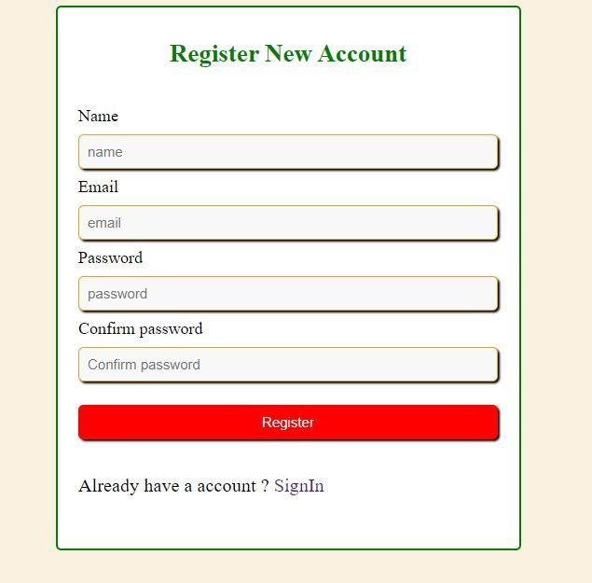

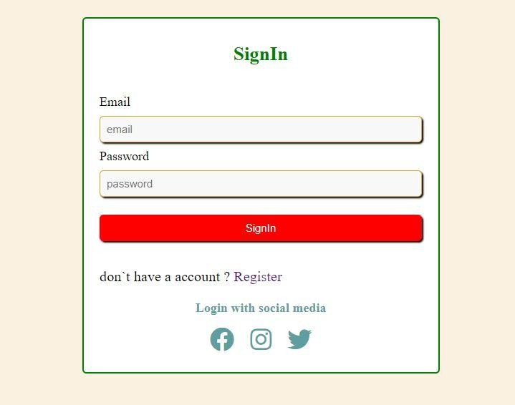



### Product Module.

### 

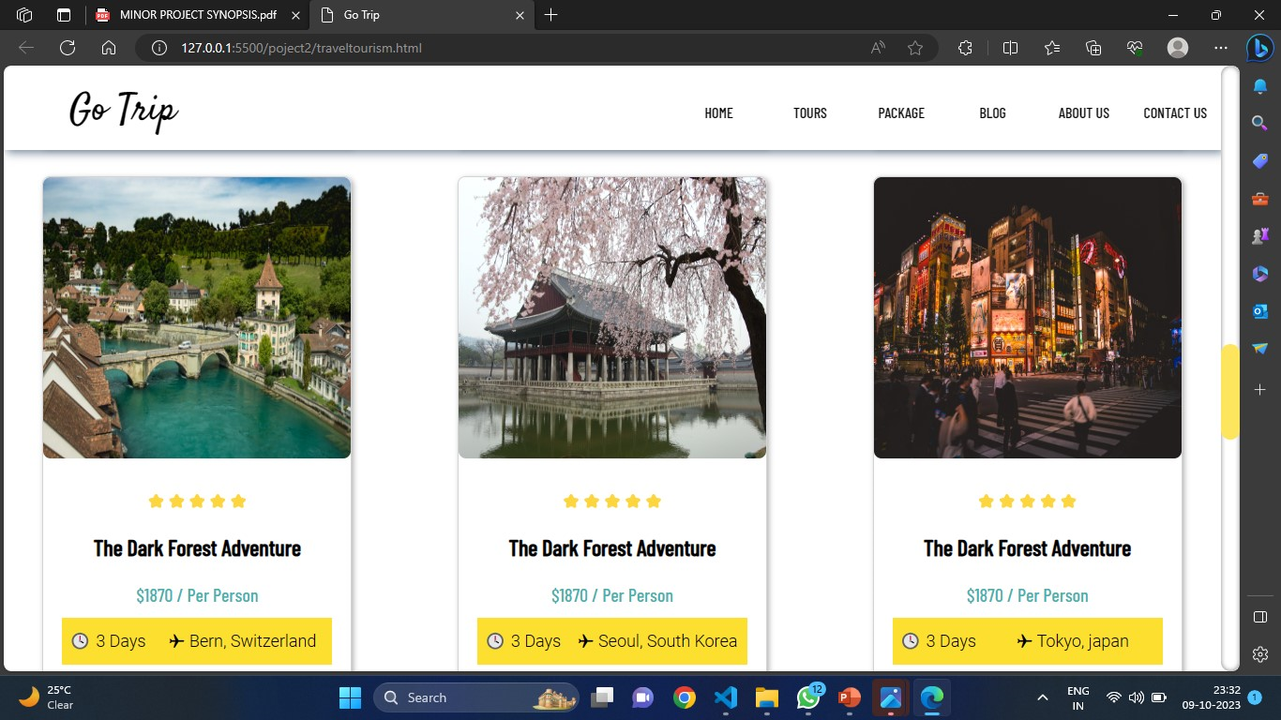



**Product Details**

## 

**Monday to Sunday**

9:30 am - 11:30 pm

All Child

**INR 518**

All Adult

**INR 2064**

## Ticket Price for Eiffel Tower (Paris)

**Eiffel Tower ticket prices** vary as per the levels and age groups. Entry fees of Eiffel Tower increases as travelers reach to the higher level.

Adults over the age of 25 need to pay 10.20 euros for tickets to the second level, while people between 12 to 24 years need to pay 5.10 euros, and children between 4 and 11 shall be charged with 2.50 euros. Admission tickets of Eiffel Tower with elevator access cost  25.50 euros, i.e. INR 2064, 12.70 euros, and 6.40 euros which is around INR 518 for the age groups respectively. Though, there is no entry fee applicable on children who come under the age of 4 years.

**Eiffel Tower entry fee** varies as per the level or floor tourist are interested to visit. For instance, tickets are costlier as one climbs to the top of the tower than the ticket price applicable for the first level.

|  |  |  |
| --- | --- | --- |
|  |  |  |
|  |  |  |



This module is further divided into different other important modules of the web-app including:

#### Category Module:

In this module different types of bakeries are categorized according to the need of the customer



Timings Opening Time: 9:00 AM

Closing Time: 12:45 AM

Last Entry Time: 11:45 PM

The Eiffel Tower also remains open every day of the week throughout the whole year.

Entry Fee Visitor Types -

Adult Ticket: 21.50 EUR (1898 INR)

Youth Ticket: 10.70 EUR (944 INR)

Child Ticket (Aged 4-11): 5.40 EUR (476 INR)

Child Under Age 4: Free Entry

Tips Make sure to reserve your tickets in advance as tickets can sell out within a few hours during the peak season.

Required Time 3-4 Hours (Approx)

Restricted Items Any large items such as a suitcase or a large bag aren t allowed. Glass containers and alcoholic beverages are also prohibited inside th e Eiffel .





## DATA FLOW DIAGRAM

### Use Case Diagram:

Use case diagram consist of use cases and actors, and shows the interaction between them. The key points are:

* The main purpose is to show the interaction between the use cases and the actor.
* To represent the system requirement from user’s perspective.
* To represent the system requirement from admin’s perspective.
* The use cases are the functions that are to be performed in the module.



# ADMIN SYSTEM

Use Case Diagram Between Admin and System



Manage Query

Manage Users

Manage Bookings

Manage Products

## DATA FLOW DIAGRAM



**0 Level**



Cancel Booking

Search Product

Query

Bookings



# USER SYSTEM

Use Case Diagram Between User and System

### Data Flow Diagram:

A DFD is graphical representation of the “flow” of the data through an information system. A DFD can also be used for the visualization of the data processing.

This context-level DFD is then “exploded” to show more details of the system being modelled.

It is used to provide the end user with the physical idea of where the data they input ultimately has an effect upon the structure of the whole system from order to dispatch to restock how any system is developed, can be determined through a data flow diagram. The appropriate register saved in database and maintained by appropriate authorities.

## DATA FLOW DIAGRAM



**1 Level**

Database

Admin/User

System

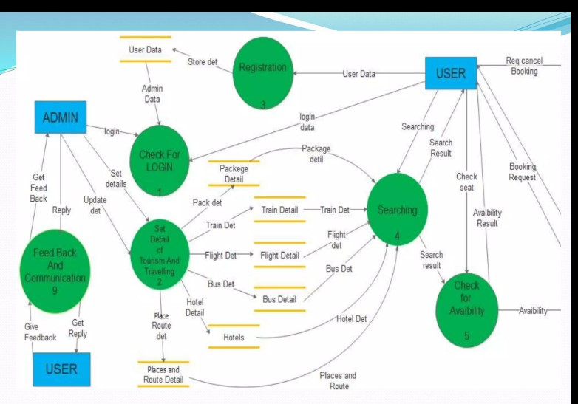

## CODE FILE STRUCTURE

* **Files**
  + **app.js**
  + **index.js**
* **Models**
  + - **userSchema.js**
* **Controllers**
  + - * **Authcontroller.js**
      * **-signin**
      * **-signup**
* **Routers**
  + - * + **authRouter.js**
* **Json files**
  + - * + **Package.json**
        + **Package-lock-json**

## CODE FILE STRUCTURE

html

* Navbar
* Banner
* Service
* Places
* About us
* Footer

styles

* scrollbar
* navbar
* banner
* service
* place
* zoom in photos
* footer
* responive



## FILE CODE

File path : ./app.js

**Description**: this file is the entry point for the server to initiate process

const express=require('express');

const app=express();

const authRouter=require('./router/authRoute');

const databaseconnect = require('./config/databaseConfig');

databaseconnect();

app.use('/api/auth/',authRouter);

app.use('/',(req,res)=>{

    res.status(200).json({data:'JWTauth server'});

});

module.exports=app;

File path:./index.js

require('dotenv').config();

const PORT=process.env.PORT||5005;

const app=require('./app');

app.listen(PORT,()=>{

    console.log(`Server is listening at http://localhost:${PORT}`);

});

## CODE FILE



**File path** : ./models/userSchema.js

const mongoose=require('mongoose');

const {Schema}=mongoose;

const JWT=require('jsonwebtoken');

const userSchema=new Schema({

    name:{

        type:String,

        require:[true,'user name is Required'],

        minLength:[5,'Name must be at least 5 char'],

        maxLength:[50,'Name must be less than 50 char'],

        trim:true

    },

    email:{

        type: String,

        required:[true,'user email is required'],

        unique:true,

        lowercase:true,

        unique:[true,'already registered']

    },

    password:{

        type: String,

        select:false

    },

    forgotPasswordToken:{

        type: String

    },

    forgotPasswordExpiryDate:{

        type: Date

    }

},{

    timestamps:true

});

userSchema.methods={

    jwtToken(){

        returnJWT.sign(

            {id:this._id,email:this.email},

          process.env.SECRET,

          {expiresIn:'24h'}

        )

    }

}

const userModel=mongoose.model('user',userSchema);

module.exports=userModel;

## CODE FILE



**File path** : ./models/authcontroller.js

const userModel = require("../model/userSchema");

const signup=async(req,res,next)=>{

    const{ name,email,password,confirmPassword}=req.body;

    console.log(name,email,password,confirmPassword);

if(!name||!email||!password||!confirmPassword){

    return res.status(400).json({

        success:"Every field is required"

    })

}

const validEmail=emailValidator.Validate(email);

if(!validEmail){

    return res.status(400).json({

        success:false,

        message:"please provide a valid email id"

    })

}

if(password!==confirmPassword){

    return res.status(400).json({

        success:false,

        message:"password and confirm password doesn't match"

    })

}

try{

const userInfo=userModel(req.body)

const result=await userInfo.save();

    return res.status(200).json({

        succuess:true,

        data:result

    });

}catch(e){

    if(e.code===11000){

        return res.status(400).json({

            success:false,

            message:'Acccount alreday exists with prrovided email id'

        })

    }

    return res.status(400).json({

        sucess:false,

        message:e.message

    })

}

}

const signin=(req,res)=>{

    const{email,password}=req.body;

    if(!email||!password){

        return res.status(400).json({

            success:false,

        message: "Every field is  mandatory"

          })

    }

    try{

    const user=await userModel

    .findOne({

        email

    })

        .select('+password');

        if(!user||user.password!==password){

            return res.status(400).json({

                success:false,

            message: "invalid cediantels"

            })

        }

const token=user.jwttoken();

user,password=undefined;

const cookieOption={

    maxAge:24*60*60*1000,

    httpOnly:true

};

res.cookie("token",token,cookieOption);

res.status(200).json({

    success:true,

    data:user

})

}catch(e){

    res.status(200).json({

        success:false,

        data:e.message

})

module.exports={

    signup

}

## CODE FILE



**File path** : html index.html

<!DOCTYPE html>

<html lang="en">

<head>

    <meta charset="UTF-8" />

    <meta http-equiv="X-UA-Compatible" content="IE=edge" />

    <meta name="viewport" content="width=device-width, initial-scale=1.0" />

    <link rel="stylesheet" href="style.css" />

    <title>Go Trip</title>

</head>

<body>

    <body>

        <!--===========Nav Bar=================-->

        <section class="nav-bar">

            <div class="logo">Go Trip</div>

            <ul class="menu">

                <li><a href="#">home</a></li>

                <li><a href="#">tours</a></li>

                <li><a href="#">package</a></li>

                <li><a href="#">blog</a></li>

                <li><a href="#">about us</a></li>

                <li><a href="#">contact us</a></li>

            </ul>

            </div>

        </section>

        <!--===============Banner================-->

        <section class="banner">

            <div class="banner-text-item">

                <div class="banner-heading">

                    <h1>Find your Next tour!</h1>

                </div>

                <form class="form">

                    <input type="text" list="mylist" placeholder="Where would you like to go?">

                    <datalist id="mylist">

                        <option>London</option>

                        <option>Canada</option>

                        <option>Monaco</option>

                        <option>France</option>

                        <option>Japan</option>

                        <option>Switzerland</option>

                        <option>Seoul</option>

                    </datalist>

                    <input type="date" class="date">

                    <a href="#" class="book">book</a>

                </form>

            </div>

        </section>

        <!--=========Services===============-->

        <section class="services">

            <div class="service-item">

                <img src="https://res.cloudinary.com/dxssqb6l8/image/upload/v1605293634/tour-guide_onzla9.png">

                <h2>8000+ Our Local Guides</h2>

            </div>

            <div class="service-item">

                <img src="https://res.cloudinary.com/dxssqb6l8/image/upload/v1605293738/reliability_jbpn4g.png">

                <h2>100% Trusted Tour Agency</h2>

            </div>

            <div class="service-item">

                <img src="https://res.cloudinary.com/dxssqb6l8/image/upload/v1605293635/experience_a3fduk.png">

                <h2>28+ Years of Travel Experience</h2>

            </div>

            <div class="service-item">

                <img src="https://res.cloudinary.com/dxssqb6l8/image/upload/v1605293634/feedback_s8z7d9.png">

                <h2>98% Our Travelers are Happy</h2>

            </div>

        </section>

        <!--==============Places===================-->

        <section class="places">

            <div class="places-text">

                <small>FEATURED TOURS PACKAGES</small>

                <h2>Favourite Places</h2>

            </div>

            <div class="cards">

                <div class="card">

                    <div class="zoom-img">

                        <div class="img-card">

                            <img

                                src="https://res.cloudinary.com/dxssqb6l8/image/upload/v1605293736/james-wheeler_xqmq2y.jpg">

                        </div>

                    </div>

                    <div class="text">

                        <span class="rating">⭐⭐⭐⭐⭐</span>

                        <h2>The Dark Forest Adventure</h2>

                        <p class="cost">$1870 / Per Person</p>

                        <div class="card-box">

                            <p class="time">🕓 3 Days</p>

                            <p class="location">✈ Vancouver, Canada</p>

                        </div>

                    </div>

                </div>

                <div class="card">

                    <div class="zoom-img">

                        <div class="img-card">

                            <img src="https://res.cloudinary.com/dxssqb6l8/image/upload/v1605293755/paris_uj8wum.jpg">

                        </div>

                    </div>

                    <div class="text">

                        <span class="rating">⭐⭐⭐⭐⭐</span>

                        <h2>The Dark Forest Adventure</h2>

                        <p class="cost">$1870 / Per Person</p>

                        <div class="card-box">

                            <p class="time">🕓 3 Days</p>

                            <p class="location">✈ Paris, France</p>

                        </div>

                    </div>

                </div>

                <div class="card">

                    <div class="zoom-img">

                        <div class="img-card">

                            <img src="https://res.cloudinary.com/dxssqb6l8/image/upload/v1605293955/monaco_usu7xb.jpg">

                        </div>

                    </div>

                    <div class="text">

                        <span class="rating">⭐⭐⭐⭐⭐</span>

                        <h2>The Dark Forest Adventure</h2>

                        <p class="cost">$1870 / Per Person</p>

                        <div class="card-box">

                            <p class="time">🕓 3 Days</p>

                            <p class="location">✈ Monaco, Monaco</p>

                        </div>

                    </div>

                </div>

                <div class="card">

                    <div class="zoom-img">

                        <div class="img-card">

                            <img

                                src="https://res.cloudinary.com/dxssqb6l8/image/upload/v1605293874/switzerland_tubxcm.jpg">

                        </div>

                    </div>

                    <div class="text">

                        <span class="rating">⭐⭐⭐⭐⭐</span>

                        <h2>The Dark Forest Adventure</h2>

                        <p class="cost">$1870 / Per Person</p>

                        <div class="card-box">

                            <p class="time">🕓 3 Days</p>

                            <p class="location">✈ Bern, Switzerland</p>

                        </div>

                    </div>

                </div>

                <div class="card">

                    <div class="zoom-img">

                        <div class="img-card">

                            <img src="https://res.cloudinary.com/dxssqb6l8/image/upload/v1605293673/korea_bxrcj5.jpg">

                        </div>

                    </div>

                    <div class="text">

                        <span class="rating">⭐⭐⭐⭐⭐</span>

                        <h2>The Dark Forest Adventure</h2>

                        <p class="cost">$1870 / Per Person</p>

                        <div class="card-box">

                            <p class="time">🕓 3 Days</p>

                            <p class="location">✈ Seoul, South Korea</p>

                        </div>

                    </div>

                </div>

                <div class="card">

                    <div class="zoom-img">

                        <div class="img-card">

                            <img

                                src="https://res.cloudinary.com/dxssqb6l8/image/upload/v1605293673/night-4336403_1920_demehp.jpg">

                        </div>

                    </div>

                    <div class="text">

                        <span class="rating">⭐⭐⭐⭐⭐</span>

                        <h2>The Dark Forest Adventure</h2>

                        <p class="cost">$1870 / Per Person</p>

                        <div class="card-box">

                            <p class="time">🕓 3 Days</p>

                            <p class="location">✈ Tokyo, japan</p>

                        </div>

                    </div>

                </div>

            </div>

        </section>

        <!--===========About Us===============-->

        <section class="about">

            <div class="about-img">

                <img src="https://res.cloudinary.com/dxssqb6l8/image/upload/v1605293719/outdoor_tjjhxk.jpg">

            </div>

            <div class="about-text">

                <small>ABOUT OUR COMPANY</small>

                <h2>We are Go Trip Ravels Support Company</h2>

                <p>Lorem ipsum dolor sit amet, consectetur adipisicing elit,

                    sed do eiusmod tempor incididunt ut labore et dolore magna aliqua.

                    Ut enim ad minim veniam, quis nostrud</p>

                <label><input type="checkbox" checked>Lorem ipsum dolor sit amet</label>

                <label><input type="checkbox" checked>consectetur adipisicing elit</label>

                <label><input type="checkbox" checked>Architecto atque consequuntur</label>

                <label><input type="checkbox" checked>cupiditate doloremque ducimus</label>

                <a href="#">ABOUT US</a>

            </div>

        </section>

        <!--===========Footer=================-->

        <div class="footer">

            <div class="links">

                <h3>Quick Links</h3>

                <ul>

                    <li>Offers & Discounts</li>

                    <li>Get Coupon</li>

                    <li>Contact Us</li>

                    <li>About</li>

                </ul>

            </div>

            <div class="links">

                <h3>New Products</h3>

                <ul>

                    <li>Woman Cloth</li>

                    <li>Fashion Accessories</li>

                    <li>Man Accessories</li>

                    <li>Rubber made Toys</li>

                </ul>

            </div>

            <div class="links">

                <h3>Support</h3>

                <ul>

                    <li>Frequently Asked Questions</li>

                    <li>Report a Payment Issue</li>

                    <li>Terms & Conditions</li>

                    <li>Privacy Policy</li>

                </ul>

            </div>

        </div>

    </body>

</html>

</body>

</html>

Code File

File path:style.css

@import url("https://fonts.googleapis.com/css2?family=Barlow+Condensed:wght@500&display=swap");

@import url("https://fonts.googleapis.com/css2?family=Satisfy&display=swap");

@import url("https://fonts.googleapis.com/css2?family=Roboto:wght@300&display=swap");

* {

  box-sizing: border-box;

  margin: 0;

}

body,

html {

  margin: 0;

  padding: 0;

}

/*------------------------Scroll Bar-----------------------*/

::-webkit-scrollbar {

  width: 20px;

}

::-webkit-scrollbar-track {

  box-shadow: inset 0 0 5px grey;

  border-radius: 10px;

}

::-webkit-scrollbar-thumb {

  background-color: #fde65e;

  border-radius: 10px;

}

::-webkit-scrollbar-thumb:hover {

  background-color: #fde02f;

}

/*========================Nav Bar=========================*/

.nav-bar {

  display: flex;

  flex-flow: row wrap;

  width: 100%;

  height: 90px;

  background-color: #fff;

  box-shadow: 3px 3px 10px lightslategray;

  align-items: center;

  justify-content: center;

  position: sticky;

  top: 0;

  z-index: 1;

}

.logo {

  flex: 1;

  font-size: 40px;

  padding: 20px;

  margin-left: 50px;

  font-family: Satisfy;

}

ul.menu {

  flex: 1;

  display: flex;

  flex-flow: row wrap;

}

.menu li {

  flex: 1;

  list-style-type: none;

  font-size: 16px;

  font-family: "Barlow Condensed";

  text-align: center;

}

.menu li a {

  text-decoration: none;

  color: #000;

  text-transform: uppercase;

}

.menu li a:hover {

  color: midnightblue;

  text-decoration: underline;

}

/*=============================Banner=============================*/

.banner {

  background-image: url("https://res.cloudinary.com/dxssqb6l8/image/upload/v1605294054/young-woman-enjoying-beautiful-scenery-of-lago-di-braies-italy-picjumbo-com_aa0fvw.jpg");

  background-size: cover;

  background-repeat: no-repeat;

  background-position: center;

  /*overflow: hidden;*/

  width: 100%;

  height: 100vh;

  text-align: center;

  position: relative;

  display: flex;

  justify-content: center;

  align-items: center;

}

.banner::before {

  content: "";

  position: absolute;

  display: block;

  top: 0;

  left: 0;

  bottom: 0;

  right: 0;

  background-color: rgba(0, 0, 0, 0.2);

  /*background-size: 100%;*/

}

.banner-text-item {

  position: absolute;

  width: 100%;

  text-align: center;

  display: flex;

  flex-flow: column wrap;

  justify-content: center;

  align-items: center;

}

.banner-heading {

  flex: 1;

}

.banner-heading h1 {

  font-size: 100px;

  font-weight: normal;

  color: #fde02f;

  font-family: Satisfy;

}

.banner-text-item .form {

  flex: 1;

  display: flex;

  flex-flow: row wrap;

  justify-content: center;

  align-items: center;

  background-color: rgba(255, 255, 255, 0.2);

  border-radius: 5px;

  width: 70%;

  padding: 1% 2%;

}

.banner-text-item input,

.banner-text-item .date,

.banner-text-item .book {

  padding: 15px;

  margin-right: 10px;

  font-size: 18px;

  font-family: Roboto;

  border-radius: 5px;

  outline: 0;

  border: none;

}

.banner-text-item input {

  width: 50%;

  flex: 2;

}

.banner-text-item .date {

  width: 20%;

  flex: 1;

}

.banner-text-item .book {

  width: 20%;

  flex: 1;

}

.banner-text-item .book {

  text-decoration: none;

  color: #000;

  text-transform: uppercase;

  padding: 15px;

  cursor: pointer;

  background-color: #fde02f;

  font-size: 16px;

  font-weight: normal;

  font-family: "Barlow Condensed";

  width: 20%;

}

/*===========================Services===========================*/

.services {

  display: flex;

  flex-flow: row;

  align-items: center;

  justify-content: center;

}

.service-item {

  flex: 1;

  padding: 50px 10px;

  border: lightcyan solid 1px;

  text-align: center;

  margin: 180px 50px;

  transition: all 1s;

  display: flex;

  flex-flow: column;

  align-items: center;

  justify-content: center;

}

.service-item:hover {

  box-shadow: 3px 3px 20px lightsteelblue;

}

.service-item h2 {

  font-family: Barlow Condensed;

  font-size: 18px;

  width: 120px;

  color: #001f38;

  flex: 1;

}

.service-item img {

  width: 60px;

  height: 60px;

  flex: 1;

}

/*=============================Places===============================*/

.places-text {

  text-align: center;

  margin-bottom: 50px;

}

.places-text small {

  font-family: Roboto;

  color: #ffc342;

  font-size: 15px;

  font-weight: bolder;

}

.places-text h2 {

  font-family: Barlow Condensed;

  font-size: 55px;

  color: #191d34;

  letter-spacing: 1px;

}

.cards {

  display: grid;

  grid-template-columns: repeat(3, 1fr);

  grid-template-rows: repeat(2, 1fr);

  grid-gap: 30px;

  align-items: center;

  justify-items: center;

  text-align: center;

}

.card {

  border: 1px solid lightgray;

  box-shadow: 2px 2px 6px 0 rgba(0, 0, 0, 0.3);

  border-top-left-radius: 8px;

  border-top-right-radius: 8px;

  width: 80%;

  height: auto;

}

.card img {

  max-width: 100%;

  height: 300px;

  border-radius: 8px;

  cursor: pointer;

}

.cards .text {

  padding: 20px;

  font-family: Barlow Condensed;

  line-height: 50px;

}

.cards .card-box {

  display: flex;

  flex-flow: row;

  background-color: #fde02f;

  font-size: 18px;

  font-family: Roboto;

  align-items: center;

  justify-content: center;

  text-align: center;

}

.cards .time {

  flex: 1;

}

.cards .location {

  flex: 2;

}

.cards .cost {

  color: #4cafad;

  font-size: 20px;

}

/*------------Zoom in Photos--------------*/

.zoom-img {

  float: left;

  position: relative;

  width: 100%;

  height: 320px;

  overflow: hidden;

}

.zoom-img .img-card {

  position: absolute;

  overflow: hidden;

}

.img-card img {

  -webkit-transition: 0.8s ease;

  transition: 0.8s ease;

}

.card:hover .zoom-img img {

  -webkit-transform: scale(1.1);

  transform: scale(1.1);

}

/*=========================About Us=========================*/

.about {

  display: flex;

  flex-flow: row wrap;

  align-items: center;

  justify-content: center;

  padding: 150px;

}

.about-img {

  flex: 1;

}

.about-img img {

  width: 500px;

  height: 700px;

  box-shadow: 2px 2px 6px 0 rgba(0, 0, 0, 0.3);

}

.about-text {

  flex: 1;

  /*width: 100px;*/

  display: flex;

  flex-flow: column wrap;

}

.about-text small,

.about-text p,

.about-text input,

.about-text a {

  flex: 1;

  font-family: Roboto;

}

.about-text small {

  color: #ffc342;

  font-size: 18px;

}

.about-text h2 {

  flex: 1;

  font-family: Barlow Condensed;

  font-size: 60px;

  color: #191d34;

  width: 450px;

}

.about-text label {

  padding-bottom: 10px;

  color: #506172;

  font-weight: bolder;

  font-family: Roboto;

  letter-spacing: 1px;

}

.about-text p {

  width: 500px;

  line-height: 30px;

  color: #506172;

  font-weight: bolder;

  padding: 50px 0;

}

.about-text a {

  background-color: #fff;

  border: 2px solid #014b85;

  text-decoration: none;

  border-radius: 5px;

  width: 180px;

  padding: 20px;

  text-align: center;

  margin-top: 50px;

  color: #014b85;

  font-weight: bolder;

  font-size: 14px;

}

.about-text a:hover {

  background-color: #014b85;

  color: #fff;

}

/*===============Footer===================*/

.footer {

  background-image: url("https://res.cloudinary.com/dxssqb6l8/image/upload/v1605293781/pine-tree_mq2sgp.jpg");

  background-size: cover;

  background-repeat: no-repeat;

  background-position: center;

  width: 100%;

  height: 670px;

  position: relative;

  display: flex;

  flex-flow: row wrap;

  justify-content: center;

  align-items: center;

}

.footer::before {

  position: absolute;

  content: "";

  display: block;

  background-color: rgba(0, 0, 36, 0.8);

  top: 0;

  left: 0;

  bottom: 0;

  right: 0;

}

.footer .links {

  position: relative;

  color: #fff;

  flex: 1;

  display: flex;

  flex-flow: column;

  justify-content: center;

  align-items: center;

}

.links ul {

  list-style-type: none;

}

.links h3 {

  font-family: Barlow Condensed;

  font-weight: normal;

  font-size: 23px;

  margin-bottom: 15px;

}

.links li {

  font-family: Roboto;

  cursor: pointer;

  padding: 15px 0;

}

.links li:hover {

  color: #ffa801;

}

/*==========================Responsive=============================*/

@media all and (max-width: 1172px) {

  .banner-text-item .form {

    display: flex;

    flex-flow: column;

    justify-content: center;

    align-items: center;

    width: 50%;

  }

  .banner-text-item .form input,

  .banner-text-item .form .date,

  .banner-text-item .form a {

    flex: 1;

    margin-bottom: 5px;

    font-size: 14px;

  }

  .banner-text-item .form input {

    width: 60%;

  }

  .banner-text-item .form .date {

    width: 30%;

  }

  .banner-text-item .form .book {

    width: 10%;

    font-size: 14px;

  }

  .banner-heading h1 {

    font-size: 60px;

  }

}

@media all and (max-width: 1414px) {

  .banner-text-item .form input {

    width: 40%;

  }

  .banner-text-item .form .date {

    width: 30%;

  }

  .banner-text-item .form .book {

    width: 20%;

    font-size: 14px;

  }

}

@media all and (max-width: 942px) {

  .nav-bar {

    display: flex;

    flex-flow: column wrap;

    justify-content: center;

    align-items: center;

    width: 100%;

    height: auto;

    text-align: center;

    position: static;

  }

  .logo {

    flex: 1;

    font-size: 30px;

    margin: 10px auto;

    font-family: Satisfy;

    color: #fde02f;

  }

  .nav-bar ul {

    display: none;

  }

  .nav-bar ul li {

    flex: 1;

    margin-bottom: 5px;

    font-size: 14px;

  }

  .services {

    display: flex;

    flex-flow: column wrap;

  }

  .services .service-item {

    flex: 1;

    margin-bottom: -130px;

    width: 400px;

  }

  .places-text {

    margin-top: 200px;

  }

}

@media all and (max-width: 928px) {

  .banner .form input,

  a {

    font-size: 12px;

  }

}

@media all and (max-width: 1173px) {

  .banner .form {

    background-color: transparent;

  }

}

@media all and (max-width: 1194px) {

  .places .card-box p {

    font-size: 14px;

  }

}

@media all and (max-width: 1086px) {

  .places .cards .text {

    line-height: 40px;

  }

  .cards .text .h2 {

    font-size: 12px;

  }

  .cards .img-card img {

    height: 260px;

  }

}

@media all and (max-width: 974px) {

  .cards {

    display: grid;

    grid-template-columns: repeat(1, 1fr);

    grid-template-rows: repeat(6, 1fr);

    grid-gap: 20px;

  }

  .card {

    width: 300px;

    height: 500px;

    margin: auto;

  }

  .cards .text {

    padding: 5px;

    font-family: Barlow Condensed;

  }

}

@media all and (max-width: 1334px) {

  .about-img img {

    width: 300px;

    height: 500px;

  }

}

@media all and (max-width: 1116px) {

  .about {

    display: flex;

    flex-flow: column wrap;

    justify-content: center;

    align-items: center;

  }

  .about-img {

    flex: 1;

    margin-bottom: 20px;

  }

  .about-text {

    flex: 1;

    margin: auto;

    text-align: center;

    display: flex;a

    flex-flow: column;

    justify-content: center;

    align-items: center;

  }

  .about-text h2 {

    font-size: 35px;

  }

  .about-img img {

    width: 400px;

    height: 400px;

  }

}

@media all and (max-width: 708px) {

  .footer {

    width: 100%;

    height: 670px;

    position: relative;

    display: flex;

    flex-flow: column wrap;

    justify-content: center;

    align-items: center;

  }



## CODE FILE



**File path :** ./package.json

**Description:** details of all the npm packages used in the project

{

  "name": "backendn",

  "version": "1.0.0",

  "description": "",

  "main": "index.js",

  "scripts": {

    "start": "nodemon ./index.js",

    "test": "echo \"Error: no test specified\" && exit 1"

  },

  "author": "jatin",

  "license": "ISC",

  "dependencies": {

    "bcrypt": "^5.1.1",

    "cookie-parser": "^1.4.6",

    "cors": "^2.8.5",

    "dotenv": "^16.3.1",

    "email-validator": "^2.0.4",

    "express": "^4.18.2",

    "jsonwebtoken": "^9.0.2",

    "mongoose": "^8.0.1",

    "nodemon": "^3.0.1"

  }

}

Filepath:./authrouter.js

const express=require('express');

const { signup} = require('../controller/authController');

const authRouter=express.Router();

authRouter.post('/signup',signup);

authRouter.post('/signin',signin);

module.exports=authRouter;

## OBJECTIVE



### Purpose:

* Google map integration.
* Trip weather forecast.
* Group discount.
* To provide a search platform where a tourist can find their tour places according to their choice.
* Provide an interface for users so they can make advertisement with us.
* We also give an opportunity for users to register as a tourist guide.
* User can select packages, user can individually is choose hotels and transportation separately.
* Administrator can add and delete information related to the customer information.



## FUTURE SCOPE

## Any tourist agency can make use of it for saving customer details in database.

## Tourism group can use it for managing their location,hotel,vehicles details.

## This application can easily implemented under various situation.

## We can add new features as and when we require.

## Reusability of this application is also possible.

## Making various database table for information storage.

## Launch this website on Internet.



## CONCLUSION

## We will include more functionality as per the user requirements.

## We want to improved our home page , as it is the main thing which attracts all user.

## Not a single website is ever consider as complete forever firstly because there is always something new requirement also are growing day by day.

* It is developed using HTML, CSS, JavaScript as frontend and Node.js and MongoDB NoSql database as backend to computerize the process of online booking of trip and make memorable journey.
  + - This project covers all the basic features required to successfully run an online traveling website.